YEAR 12 Essentials Mathematics
Semester 1 2017
Test 4 – Bivariate Data and Bias

.

Total Marks: 20 marks
Name: ______________________ Total Time: 30 minutes


Full working out must be shown to get full marks.

Attempt all questions

Total Time: 30 minutes

Resources allowed:

1 A4 page, (1 side) of hand written notes, ruler

Calculator

Question 1: (12 marks: 5, 2, 1, 2, 2)

A Mathematics teacher proposed that it was possible to predict a student’s final exam mark using that student’s first semester exam mark.

- Firstly she put the previous year’s marks onto a scatterplot. Use the data below to show what her scatterplot would have looked like.

Student | A | B | C | D | E | F | G | H | I | J | K | L | M | N | O | P
1st Exam % | 48 | 65 | 87 | 60 | 53 | 74 | 82 | 85 | 67 | 95 | 43 | 59 | 60 | 77 | 82 | 45
2nd Exam  % | 50 | 67 | 80 | 59 | 70 | 69 | 80 | 89 | 73 | 95 | 60 | 62 | 58 | 75 | 84 | 55

- Describe the relationship between the first and second exam results.

- Complete this sentence: If a student’s first exam results are high, than ……………

- Use a line of best fit to predict the score for a student who missed the second exam but scored 75% in the first exam.

- Student J scored 95% in both his fiirst and second exams. Does this mean that he can expect to score 95% in his exams in the next year too? Justify your answer.

Question 2: (2 marks)

An internet provider emailed its customers to ask them if they supported a new government tax on broadband. They then sent this data to the government who replied that their survey was biased. Give two reasons to support the government’s claim of bias.

Question 3: (2 marks)
Is the following statement true or false? Give a reason to justify your answer.
Random sampling is a good way to reduce response bias.

Question 4: [4 marks:1, 1, 2]

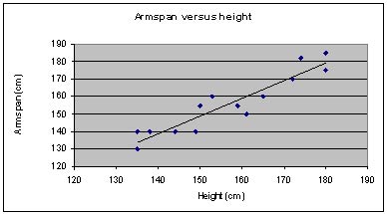

- Use the scattergraph above to determine the approximate armspan of a person who is 150cm tall.

- Now determine the approximate height of a person who has an armspan of 170cm.

- What relationship do you see between a person’s height and their armspan?

~END OF TEST~

